Anjali

[Email address]

Abstract

[Draw your reader in with an engaging abstract. It is typically a short summary of the document.   
When you’re ready to add your content, just click here and start typing.]

**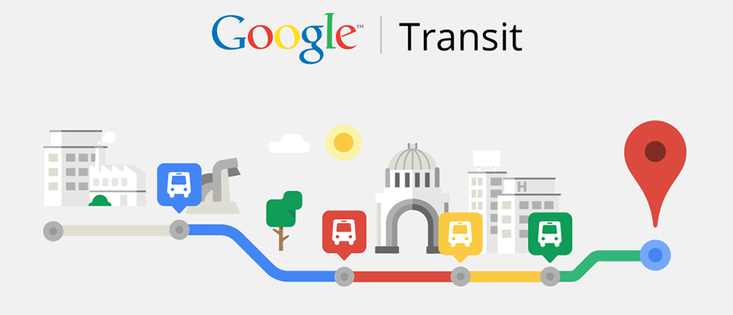**

Goa on Google

Bringing information to fingertips

NewYug Technologies

F-5, Mansukh Apt, B.B.Borkar Rd, Alto Porvorim Goa 403521

**Proposal for Goa Tourism**

Goa Tourism Department, 2nd Floor, Parytan Bhavan, Patto – Panaji, Goa 403001

Contents

[Executive Summary 2](#_Toc461583457)

[Existing problem 2](#_Toc461583458)

[The solution 2](#_Toc461583459)

[Our offering 3](#_Toc461583460)

[The benefit 3](#_Toc461583461)

[Technical solution 5](#_Toc461583462)

[Google support 5](#_Toc461583463)

[Our offering 5](#_Toc461583464)

[Data entry 6](#_Toc461583465)

[Passenger Experience 7](#_Toc461583466)

[Financials 7](#_Toc461583467)

[Engagement with GTDC 7](#_Toc461583468)

[Additional services 8](#_Toc461583469)

[The Goa Calendar 8](#_Toc461583470)

[The Goa Map 8](#_Toc461583471)

[Taxis on Google Maps 8](#_Toc461583472)

[Summary 8](#_Toc461583473)

# Executive Summary

## Existing problem

Goa is witnessing rampant rise in the usage of personal vehicles by locals as well as tourists. This is taking a major toll on the state's infrastructure, peacefulness and environment. Most people prefer personal vehicles due to lack of awareness of public transport options to get to their destination.

## The solution

Goa's roads and waterways have a strong public transport operated by the Govt. and private operators. The convenience of having the time-table of all public transport services in Goa available on the internet, will translate into people being able to plan their commute in advance and avoid the hassles of using personal vehicles.

## Our offering

We offer on online software that allows transit agencies to publish their routes, stops and timetables to Google Maps. Once the data is published, tourists as well as residents will be able to access travel information without the need of any new app on their phones.

## The benefit

Tourists visiting the state for a limited period will be able to plan their visit in advance long before their visit. Tourists will be able to travel all over Goa without using personal vehicles. Goa will see sustainable tourism development without an additional burden on infrastructure.

The state of Goa, India is famous for its beaches and places of worship, and tourism is its primary industry. Tourism is generally focused on the coastal areas of Goa, with an equal amount of tourist activity inland. Goa sees a large number of foreign tourists as well as a lot of Indian tourists.

The state of Goa has various beautiful Beaches, Temples, Churches, Heritage homes, Wildlife sanctuaries, Museums etc. Most of these tourist attractions are well connected by public transit.

**BUT**

Many of the tourists visiting Goa are forced to rent bikes or cab and pay exorbitant prices of rent thus spoiling their entire experience of the beautiful dreamland state of Goa as they do not have access to timings of Goa’s public transport.

**THIS SCENARIO CAN BE CHANGED**

If a tourist knows exactly what time a particular bus will come to a particular bus stop which will take him to his destination then tourists will certainly prefer using public transport thus reducing a lot of discomfort to them.

# Technical solution

## Google support

Google allows the user to obtain driving, walking and public transit directions between any two locations in the world. The public transit options are available on Google Maps only if the transport providers upload their routes, stops, trip timings to Google. The process of providing the timetables to Google is cumbersome. The data needs to be provided in Google's GTFS format. The entire data can run into thousands of lines of text files. Most importantly, the geo-location of stops has to be accurately provided as a latitude and longitude.

## Our offering

TARA

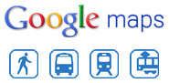

Provide fleet settings

GTFS data

Travel options

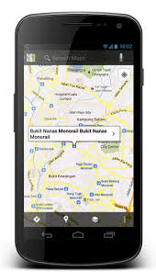

Google Maps on mobile

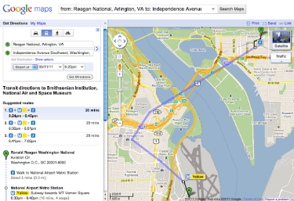

Google Maps on website

The Transit Agency Route Administrator (TARA) simplifies the process of generating the data. It provides a simple visual tool for feeding time-table details of a transit agency.

* The stops can be accurately marked on a map.
* It allows two stops on opposites sides of the road to be linked to each other as peer-stops.
* Each route operated by the agency can be marked on the map by choosing stops that have been previously marked.
* Onward and Return trips on the route can be added by specifying start times of the trips.
* The timings at intermediate stops along the route can be automatically computed by the tool.
* The tool allows offline creation of time-tables in Microsoft Excel.
* The tool generates a passenger-friendly timetable that can be printed and pasted at different locations of the city.
* It can generate the GTFS file that can be uploaded to Google.

## Data entry

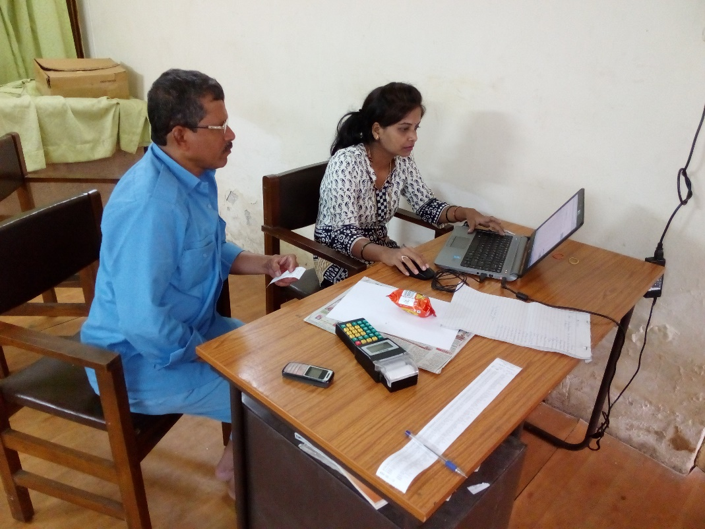

* Data entry is performed with the assistance of a driver.
* The driver guides the operator in identifying the precise location of bus stops on a map.

# Passenger Experience

A passenger can search for travel options between any two points on a Google Maps application. The results provide step-by-step directions including different modes such as Walking, Ferries, and Buses.

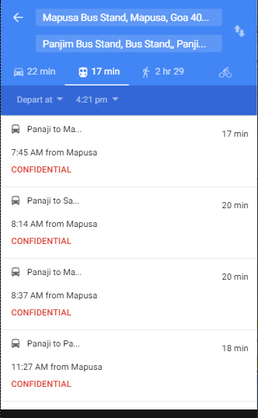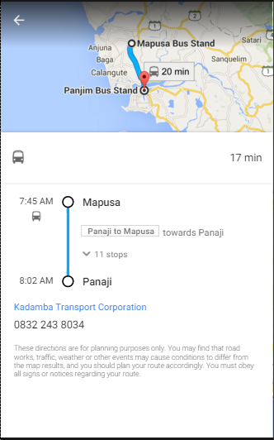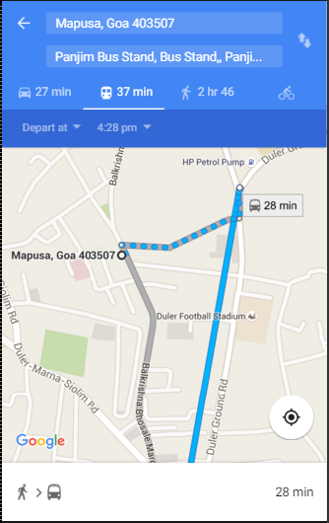

# Financials

# Engagement with GTDC

Data entry by Kadamba is in progress. The routes and stops used by Kadamba are the same as that used by private operators. Hence it should be possible for us to reuse the data that have been entered so far.

In Phase 1, GTDC will upload only the timetables of routes that are shared by Kadamba and Private operators.

In Phase 2, GTDC will upload additional routes and stops.

## Role of NewYug

NewYug will provide training to about 5 employees of GTDC to use the software. This training will be conducted over a period of three days.

## Role of GTDC

GTDC will obtain the

# Additional services

## The Goa Calendar

**[http://bit.do/ingoa](http://bit.do/ingoa" \t "_blank)**

## The Goa Map

## Taxis on Google Maps

# Summary

This project will place Goa among the few places in India that provide public transport options to citizens at their fingertips. Any agency that subscribes to this service should expect increased revenue from passengers as citizens will begin to turn to public transport. The city/state will witness lesser traffic and cleaner air. Reduced fuel consumption will be a positive side effect of this project.

**WE HAVE A SOLUTION FOR THIS !!**

**NewYug Technologies brings to you Google based Technology solution for this problem by integrating local transit timetables with Google Maps & Google Transit.**

**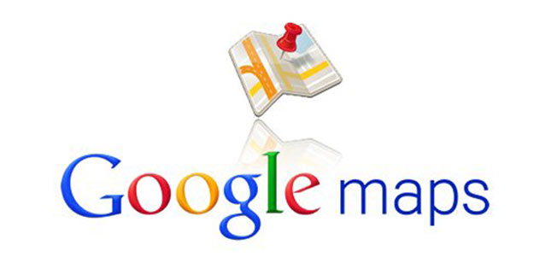**

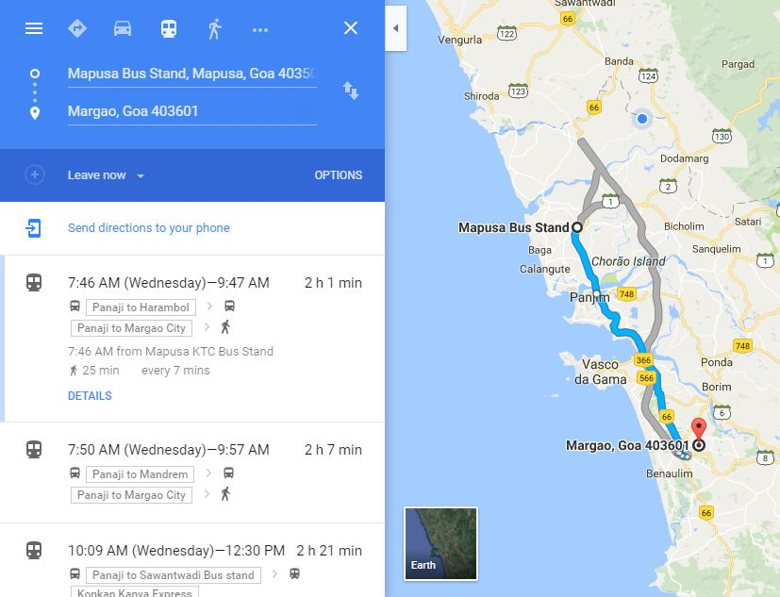As a pilot project we have hosted two agencies based in Goa on Google Maps namely Kadamba Transport Corporation Ltd. & Ferryboat Service run by River Navigation Department

